**Scalability and Performance**

1. First, we fixed wait time for each instruction to 0.1 and the gradually we increased the number of clients, starting from 1 to 100.

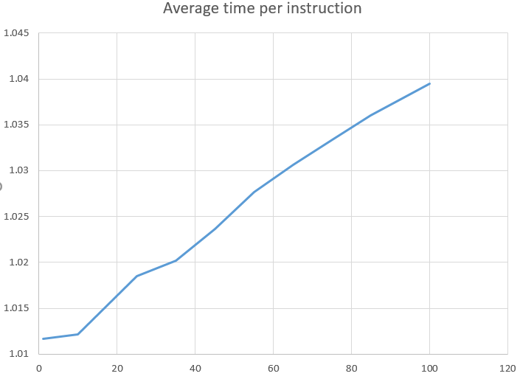

**Wait time – 0.1 s and Number of instructions is 6.**

**Average time per instruction- Time/Total transactions**

|  |  |  |
| --- | --- | --- |
| **Number of Clients** | **Time** | **Average Time per instructions** |
| 1 | 6.07 | 1.011 |
| 10 | 6.073 | 1.012 |
| 25 | 6.111 | 1.0185 |
| 35 | 6.121 | 1.020 |
| 45 | 6.142 | 1.023 |
| 55 | 6.166 | 1.027 |
| 65 | 6.184 | 1.030 |
| 75 | 6.2 | 1.033 |
| 85 | 6.216 | 1.036 |
| 100 | 6.237 | 1.039 |

**Case 2:** In this case, we are fixing clients size to 30 and increasing transaction wait time starting from 0.1 till 1.

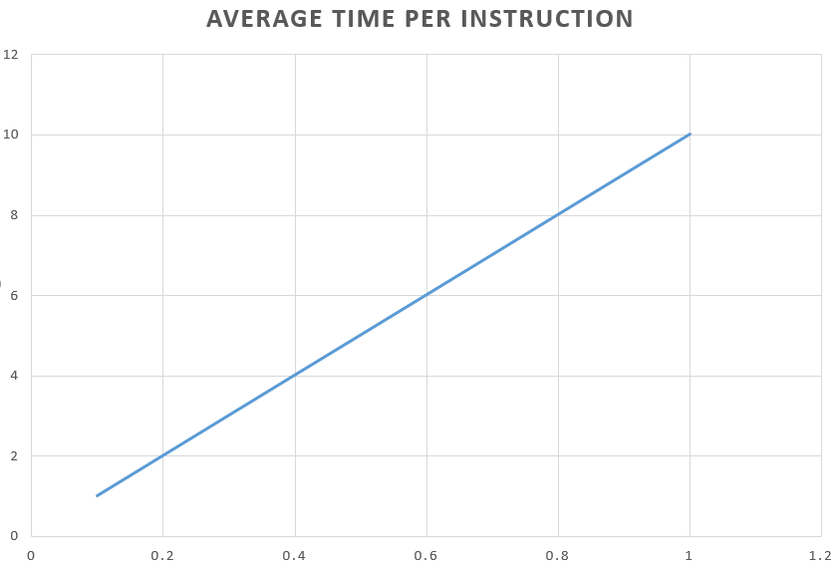

**Number of clients is fixed to 30**

**Average time per instruction = (time/no of clients * number of instructions)**

|  |  |  |
| --- | --- | --- |
| **Wait time** | **Time** | **Average Time per instructions** |
| 0.1 | 6.11 | 1.011 |
| 0.2 | 12.125 | 2.020 |
| 0.3 | 18.145 | 3.024 |
| 0.4 | 24.139 | 4.023 |
| 0.5 | 30.128 | 5.0213 |
| 0.6 | 36.131 | 6.021 |
| 0.7 | 42.129 | 7.0125 |
| 0.8 | 48.138 | 8.023 |
| 0.9 | 54.13 | 9.021 |
| 1 | 60.122 | 10.023 |